**Turner Bands**

# **Overview**

The Turner Band strategy consists of one plot of the angle of the 200-length exponential moving average (EMA200) which is checked against 10 plots of the standard deviations of the angle of the 200-length exponential moving average. As the angle plot moves across the standard deviation lines, buys and sells are initiated at the correct pass-overs described further down in this document. This strategy can be applied to any stock but it is best to start it at the beginning of the trading day.

At first glance, this strategy may seem like a convoluted mess, but when the logic of a program is applied, it is unstoppable. The reason for this is the nature of the EMA200. Among other things, the EMA200 has the ability to indicate and predict both an uptrend and a downtrend. A famous quote from [Paul Tudor Jones](https://en.wikipedia.org/wiki/Paul_Tudor_Jones), in the book called Moving Averages 101, calls attention to this fact.

*“I have one strong rule and that is when it comes to a stock, if it’s above the 200-day moving average, I’m gonna be long it, and if it’s below it, I’m either not gonna own it or I’m gonna be short it, period end of story and I just let that govern every single thing that I do.”*

The Turner Bands do not use a 200-day moving average but they do use a 200-minute moving average. The standard deviation lines are all using a 120-minute length. As seen below, using the EMA200, the Turner Bands have the ability to avoid downtrends and take advantage of up trends when they exist.

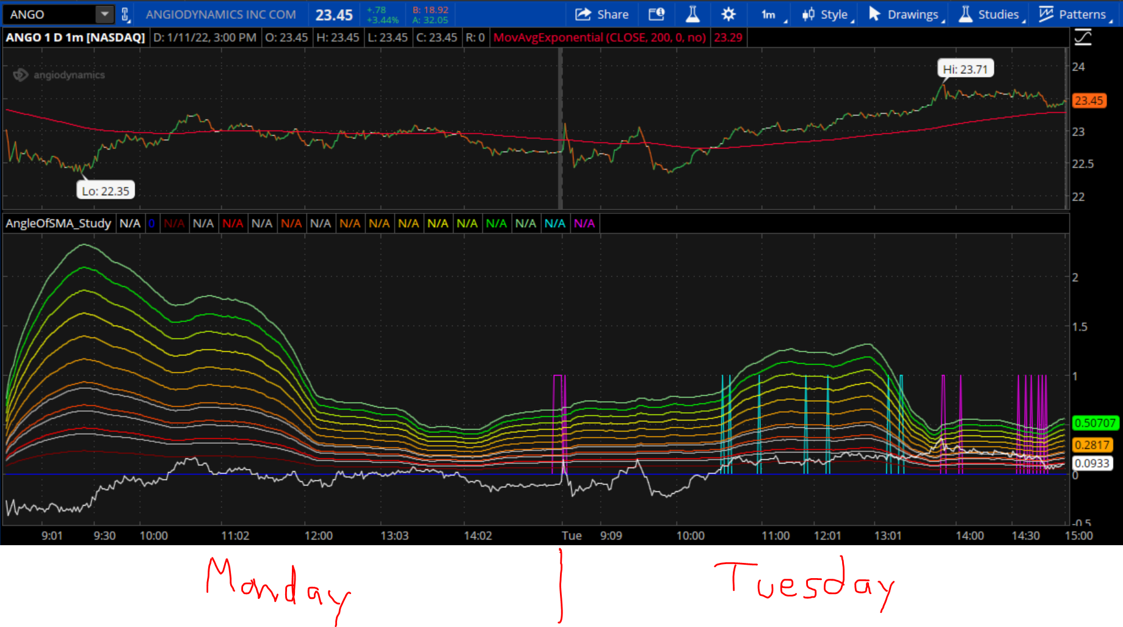

# **Visual Representation from Thinkorswim**

In the below picture we see two graphs for the stock symbol KNBE. Its price is depicted in the top graph as a series of green and red lines, indicating whether the price is going up or down at any given time. The price value is depicted on the vertical axis (far right side) while time is seen on the horizontal axis (bottom). The EMA200 is the red plot on the top graph.

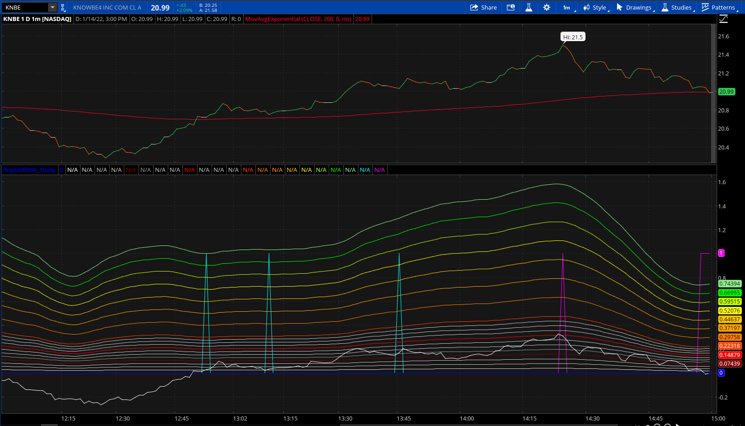

The bottom graph is the graph of the Turner Bands which I will now list below. Please note that colors are arbitrary and can be assigned in any way but in the above picture, I begin listing all lines from the bottom, going up.

* White sporadic line
  + The angle of the EMA200
* Horizontal Dark Blue line
  + Zero degrees (origin)
* First Grey line
  + 0.25 times the first standard deviation of the angle of the EMA200
* Second Grey line
  + 0.5 times the first standard deviation of the angle of the EMA200
* Third Grey line
  + 0.75 times the first standard deviation of the angle of the EMA200
* Dark Red line
  + First standard deviation of the angle of the EMA200
* Fourth Grey line
  + 1.25 times the first standard deviation of the angle of the EMA200
* Fifth Grey line
  + 1.5 times the first standard deviation of the angle of the EMA200
* Sixth Grey line
  + 1.75 times the first standard deviation of the angle of the EMA200
* Red line
  + Second standard deviation of the angle of the EMA200
* Seventh Grey line
  + 2.25 times the first standard deviation of the angle of the EMA200
* Eighth Grey line
  + 2.5 times the first standard deviation of the angle of the EMA200
* Nineth Grey line
  + 2.75 times the first standard deviation of the angle of the EMA200
* Light Red line
  + Third standard deviation of the angle of the EMA200
* Dark Orange line
  + Fourth standard deviation of the angle of the EMA200
* Orange line
  + Fifth standard deviation of the angle of the EMA200
* Light Orange line
  + Sixth standard deviation of the angle of the EMA200
* Yellow line
  + Seventh standard deviation of the angle of the EMA200
* Light green line
  + Eighth standard deviation of the angle of the EMA200
* Green line
  + Nineth standard deviation of the angle of the EMA200
* Avocado line
  + Tenth standard deviation of the angle of the EMA200
* Light Blue up arrows
  + Buy indicators
* Magenta up arrows
  + Sell indicators

# **Rules for Trades**

1. Only one buy is allowed at a time per stock, until a sell closes the trade. If a buy is initiated, no other buy can occur until a sell has first closed the trade.

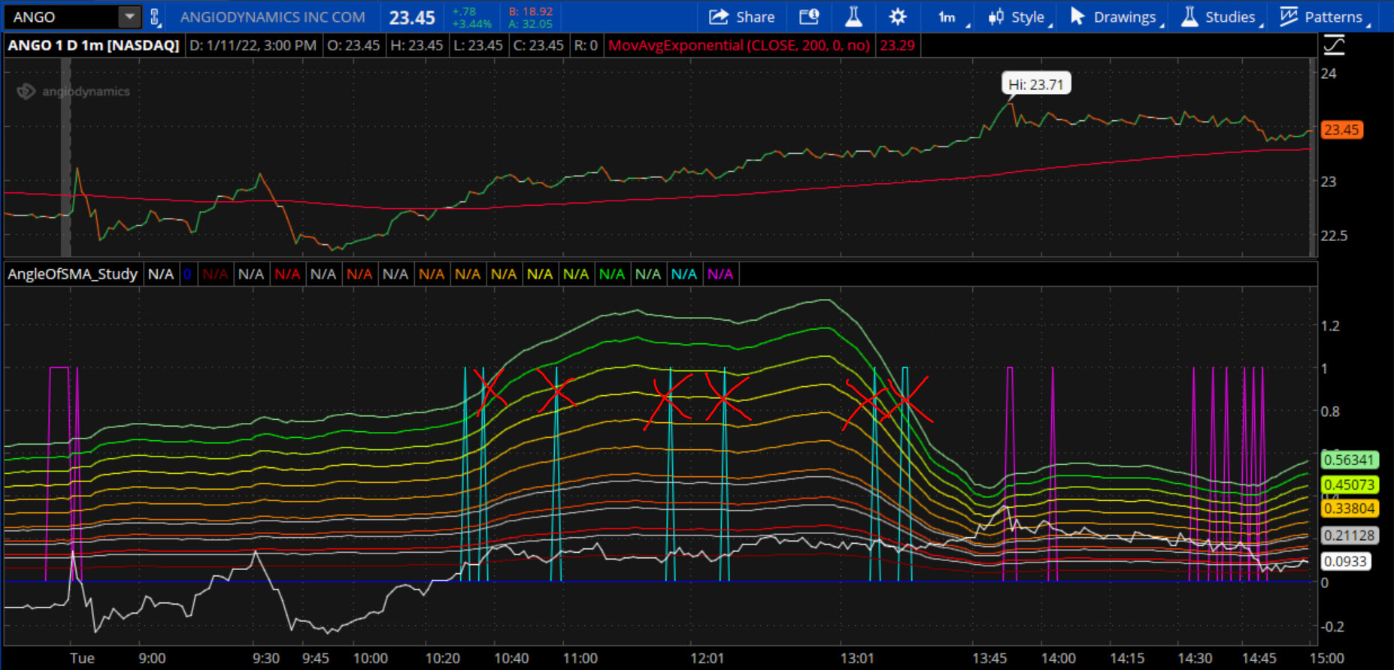

1. Likewise, only the first sell that closes the trade will count.

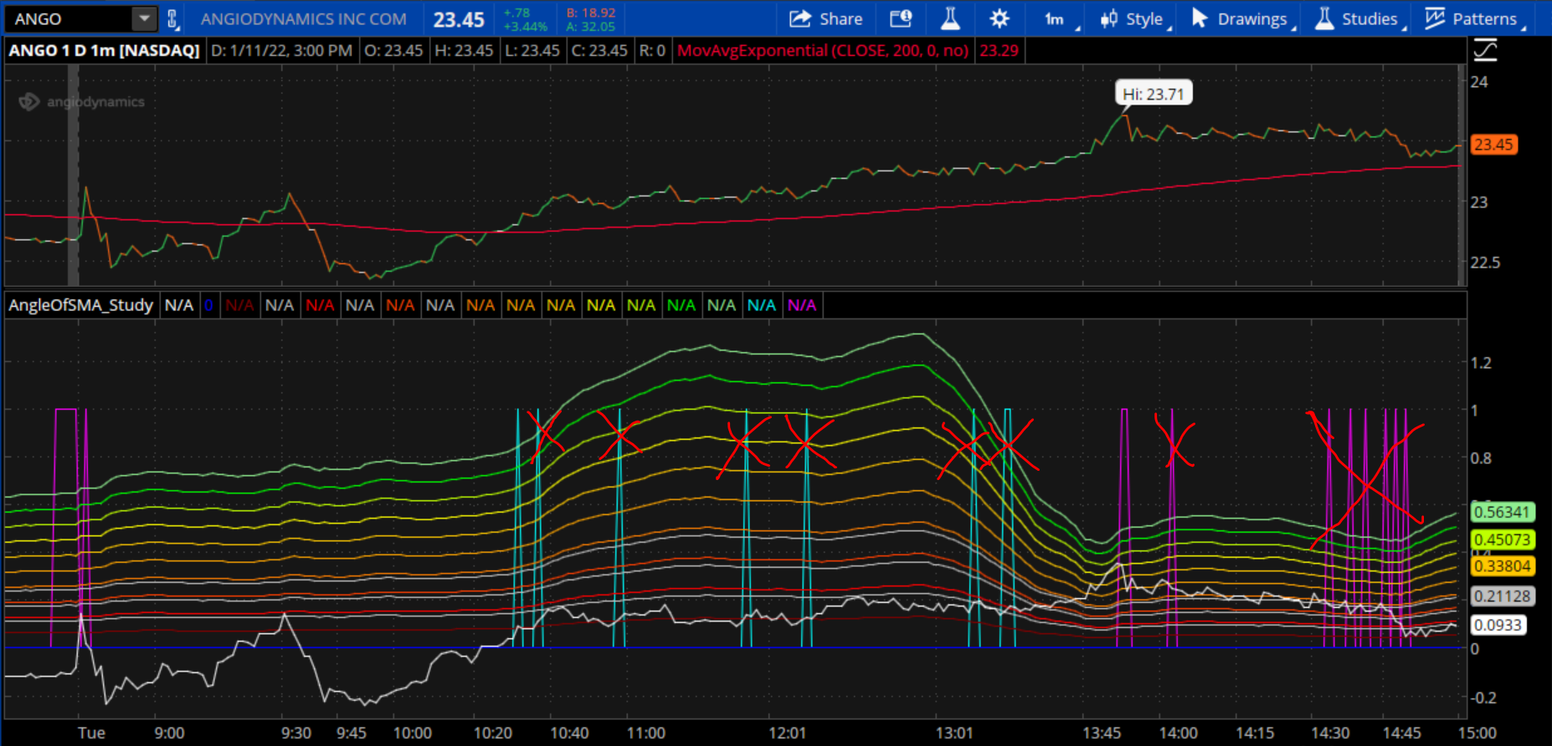

1. No buys can occur if the current price is below the EMA200.
2. No buys can occur within the last half-hour of the open market.
3. No buys can occur unless the current close price is below the previous 3rd, 6th, and 9th close price.
4. ALL trades must be closed prior to 3 PM CST. In this paper, all trades are sold at 14:55 though testing will show how much time we have to successfully sell all open trades before closing time.

# **A Good Buy**

1. When the closing price is above the EMA200 AND the angle of the EMA200 crosses above the 0.25 times the first standard deviation line AND secondsRemainingInDay > 1800 AND changeInStdDev > 0.

or

1. When the closing price is above the EMA200 AND the angle of the EMA200 crosses above the 0.75 times the first standard deviation line AND the current closing price is less than the previous 3rd, 6th, and 9th closing prices AND secondsRemainingInDay > 1800 AND changeInStdDev > 0.

or

1. When the closing price is above the EMA200 AND the angle of the EMA200 crosses above the first standard deviation line AND the current closing price is less than the previous 3rd, 6th, and 9th closing prices AND secondsRemainingInDay > 1800 AND changeInStdDev > 0.

or

1. When the closing price is above the EMA200 AND the angle of the EMA200 crosses above the 1.25 times the first standard deviation line AND the current closing price is less than the previous 3rd, 6th, and 9th closing prices AND secondsRemainingInDay > 1800 AND changeInStdDev > 0.

or

1. When the closing price is above the EMA200 AND the angle of the EMA200 crosses above the 1.75 times the first standard deviation line AND the current closing price is less than the previous 3rd, 6th, and 9th closing prices AND secondsRemainingInDay > 1800 AND changeInStdDev > 0.

or

1. When the closing price is above the EMA200 AND the angle of the EMA200 crosses above the 2 times the first standard deviation line AND the current closing price is less than the previous 3rd, 6th, and 9th closing prices AND secondsRemainingInDay > 1800 AND changeInStdDev > 0.

# **A Good Sell**

1. When the closing price crosses below the EMA200 – 1.00.

or

1. When the closing price is above the EMA200 AND the angle of the EMA200 crosses below the 10 times the standard deviation line AND the current closing price is greater than the previous 3rd, 6th, and 9th closing prices AND changeInStdDev is less than 0.

or

1. When the closing price is above the EMA200 AND the angle of the EMA200 crosses below the 9 times the standard deviation line AND the current closing price is greater than the previous 3rd, 6th, and 9th closing prices AND changeInStdDev is less than 0.

or

1. When the closing price is above the EMA200 AND the angle of the EMA200 crosses below the 8 times the standard deviation line AND the current closing price is greater than the previous 3rd, 6th, and 9th closing prices AND changeInStdDev is less than 0.

or

1. When the closing price is above the EMA200 AND the angle of the EMA200 crosses below the 7 times the standard deviation line AND the current closing price is greater than the previous 3rd, 6th, and 9th closing prices AND changeInStdDev is less than 0.

or

1. When the closing price is above the EMA200 AND the angle of the EMA200 crosses below the 6 times the standard deviation line AND the current closing price is greater than the previous 3rd, 6th, and 9th closing prices AND changeInStdDev is less than 0.

or

1. When the closing price is above the EMA200 AND the angle of the EMA200 crosses below the 5 times the standard deviation line AND the current closing price is greater than the previous 3rd, 6th, and 9th closing prices AND changeInStdDev is less than 0.

or

1. When the closing price is above the EMA200 AND the angle of the EMA200 crosses below the 4 times the standard deviation line AND the current closing price is greater than the previous 3rd, 6th, and 9th closing prices AND changeInStdDev is less than 0.

or

1. When the closing price is above the EMA200 AND the angle of the EMA200 crosses below the 3 times the standard deviation line AND the current closing price is greater than the previous 3rd, 6th, and 9th closing prices AND changeInStdDev is less than 0.

or

1. When the closing price is above the EMA200 AND the angle of the EMA200 crosses below the 2.75 times the standard deviation line AND the current closing price is greater than the previous 3rd, 6th, and 9th closing prices AND changeInStdDev is less than 0.

or

1. When the closing price is above the EMA200 AND the angle of the EMA200 crosses below the 2.5 times the standard deviation line AND the current closing price is greater than the previous 3rd, 6th, and 9th closing prices AND changeInStdDev is less than 0.

or

1. When the closing price is above the EMA200 AND the angle of the EMA200 crosses below the 2 times the standard deviation line AND the current closing price is greater than the previous 3rd, 6th, and 9th closing prices AND changeInStdDev is less than 0.

# **How Stocks are Chosen**

The Turner Bands will work on any stock that has periodic motion. This being said, some stocks may have periodic motion, but their change in price is not very much or their price is too high for the amount of risk you need to take. In this document, stocks were chosen with the below 3 filters on TOS because of the amount that is currently in the live account.

1. Close price is between $20.00 and $27.00.
   1. This enables a maximum risk per stock at $2700 with a 100-share purchase.
2. Minimum percent change for the stock is 1%.
   1. This enables a minimum growth of the stock of 1% which usually allows for a 1-dollar increment/decrement in profit.
3. Stock is above the EMA200.

# **Account Risk Limit**

An algorithm should be in place which keeps track of the total amount of Available Dollars to risk as well as each buy-in amount. For example, if I have $30,000 dollars total in my account, I do not want the total amount of risk to go passed $30,000. As the account balance grows, more stocks can be bought into. Written below is an untested python algorithm that may be able to do this:

  import numpy as np

            buyPricesOfStocks = {}  #  array of buyInPrices

            riskAmountArray = np.array()

            numberOfShares = 100

            totalAccountBalance = 30000

            for buyPriceOfOneStock in buyPricesOfStocks:

                riskAmount = buyPriceOfOneStock * numberOfShares

                riskAmountArray.append(riskAmount)

            totalRiskAmount = np.sum(riskAmountArray)

            if totalRiskAmount < totalAccountBalance:

                for buyPriceOfOneStock in buyPricesOfStocks:

                    riskAmount = buyPriceOfOneStock * numberOfShares

                    riskAmountArray.append(riskAmount)

                totalRiskAmount = np.sum(riskAmountArray)

# **Risk Mitigation**

There are a few thresholds that allow for risk to mitigated to a minimum in the Turner Bands strategy.

1. Every buy should be placed should be placed with a $1.50 Stop limit.
   1. This is to ensure that if the communication signal between the app and TDA’s server is cut off for any reason, the trade can still move forward with a bottom threshold for exiting the trade.
2. The first sell trigger check, should be if the closing price has dropped below the EMA200 - $1.00.
   1. At first, I had this threshold as the EMA200 itself. But this produced the classic “threshold syndrome” as I like to call it, where the trade is exited at a loss because it hits the threshold and then immediately buys in again right after and then sells again at the threshold for a loss, and continues in that pattern while the closing price maintains an average position around the EMA200. For this reason, a threshold is created below the EMA200 which allows the closing price to come back up as it usually does like a rubber band snapping back with tension.

# **Strategic Dependency Optimization**

There are three basic “independent variables” that this strategy relies on (sells particularly). I will explain more about these in the Buy and Sell Rules sections. Please note that every effort should be made to optimize as the amount of profit is increases substantially and the amount of unsuccessful trades goes almost to zero.

1. The angle of the EMA200 to cross over/under specified standard deviation.
2. The current closing price position relative to the third, sixth, and nineth position.
3. The change in the standard deviation’s sign (positive/negative).

When all of the above are combined in different ways, the strategy is optimized. Though, in the programming this may be too much and is NOT necessary for the strategy to provide a net profit. Normal operation is using only standard deviations 1 through 10. Though, I have found that the more standard deviation lines you have like 0.25 * first standard dev and 0.50 and 0.75 will provide more options to get the best sells. I also found that by having options for both a positive and negative sign in the change in standard deviation, also greatly expanded the selling capability. I also found that by having options for both a greater than/less than signs in the current closing price position relative to the third, sixth, and nineth position, also greatly expanded the selling capability. Examples of these below using thinkScript.

1. The angle of the EMA200 to cross over/under specified standard deviation.

close >= sma200 and angleOfSma200 crosses below standardDeviationOfSMA200Angle3 and close[3] < close[0] and close[6] < close[0] and close[9] < close[0] and changeInStdDev < 0

or

close >= sma200 and angleOfSma200 crosses below standardDeviationOfSMA200Angle2_75 and close[3] < close[0] and close[6] < close[0] and close[9] < close[0] and changeInStdDev < 0

or

close >= sma200 and angleOfSma200 crosses below standardDeviationOfSMA200Angle2_5 and close[3] < close[0] and close[6] < close[0] and close[9] < close[0] and changeInStdDev < 0

or…

1. The current closing price position relative to the third, sixth, and nineth position.

close >= sma200 and angleOfSma200 crosses below standardDeviationOfSMA200Angle3 and close[3] < close[0] and close[6] < close[0] and close[9] < close[0] and changeInStdDev < 0

or

close >= sma200 and angleOfSma200 crosses below standardDeviationOfSMA200Angle3 and close[3] > close[0] and close[6] > close[0] and close[9] > close[0] and changeInStdDev < 0

or…

1. The change in the standard deviation’s sign (positive/negative).

close >= sma200 and angleOfSma200 crosses below standardDeviationOfSMA200Angle3 and close[3] < close[0] and close[6] < close[0] and close[9] < close[0] and changeInStdDev < 0

or

close >= sma200 and angleOfSma200 crosses below standardDeviationOfSMA200Angle3 and close[3] > close[0] and close[6] > close[0] and close[9] > close[0] and changeInStdDev > 0

# **Further Optimization**

There are some other things we can try to maximize this strategy. For example, I have noticed that the stocks generally behave the same way at the the first half of the day and the last half of the day. The Turner Bands seem to show a “peak” in standard deviations from 8:30am to 11:45am and a “trough” from 11:45am to 1:45pm and another “peak” from 1:45pm to close. This fact combined with changeInStdDev can be used to predict further create the best trades. Example below:

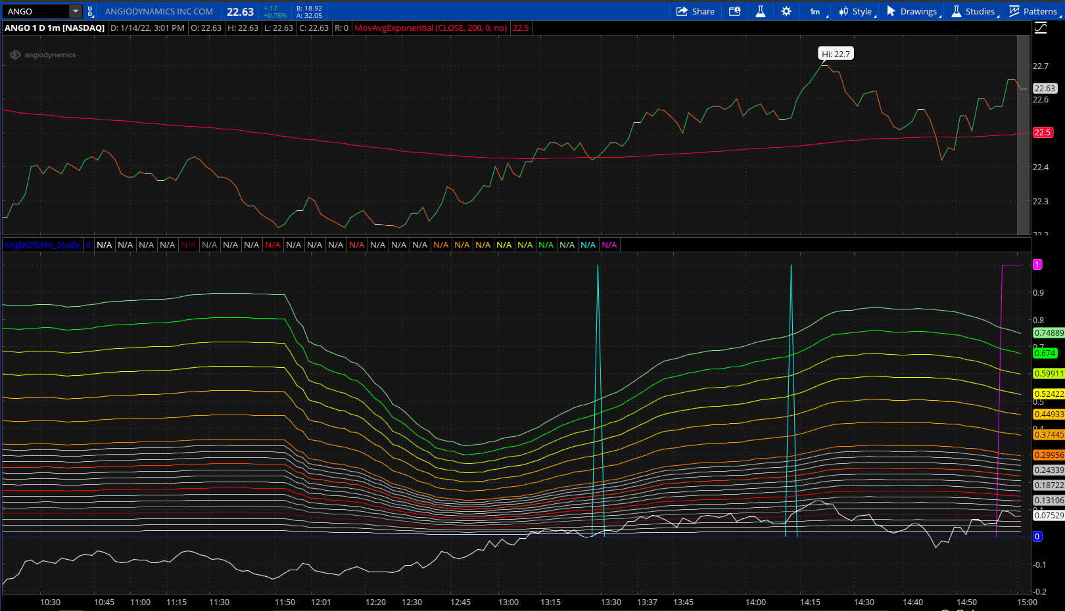

It buys at just before 13:30pm as the second half of the day shows an upward standard deviation slope. It then sells at the end of the day hitting its 14:55 time limit. Currently, all of the sell triggers are set to only occur on aa downward slope of the standard deviation but if we add one for the 1.5 standard deviation and changeInStdDev > 0, we get a new trade with the same buyIn but a new sell point at the highest point of the day:

